Monopoly Industries
Banking App
Samantha Brayne
11-21-2021

Contents
Introduction 2
What is the purpose of this application? 2
Walk through of the application 2
Add account 3
View your accounts 7
Withdrawals 9
Deposit 14
Save to a new file 18

Introduction

What is the purpose of this application?
The inspiration of this application was taken from the CommBank app(link: https://play.google.com/store/apps/details?id=com.commbank.netbank ), I personally use my app every day, since the start of the pandemic I have tried to save money rather than living paycheck to paycheck. During the past year, I have made small saving goals by creating different accounts and separating the money to visually see where my spending goes, and how I can improve in certain areas.
This application has basic functionality, such as creating new bank accounts with account number, name of account and the balance. Withdrawals and deposits from specified accounts is possible which changes the balance available. The user may also save and load files by entering the file name.

Walk through of the application
Here we have included samples and screenshots of the program with some brief instructions on what you can or cannot do within the program. All the operations listed in the menu below, are listed in the following sections.
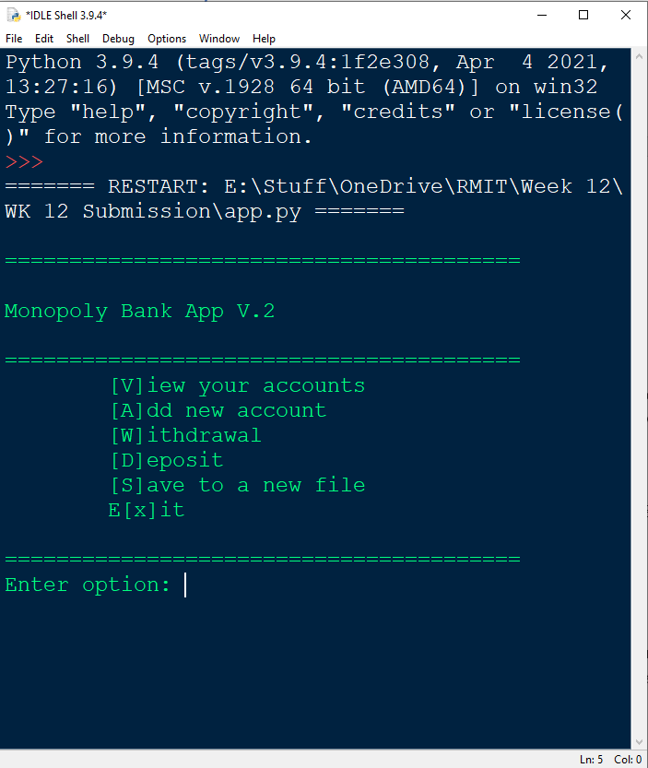

Add account

Account creation is very simple from the main menu, enter A, a capital or lower case will be accepted.
The program will prompt you to enter your account number. If for some reason you make a typo such as entering a letter or symbol. In the example below, I have made a few errors and the program has confirmed that the answer I gave was not right.
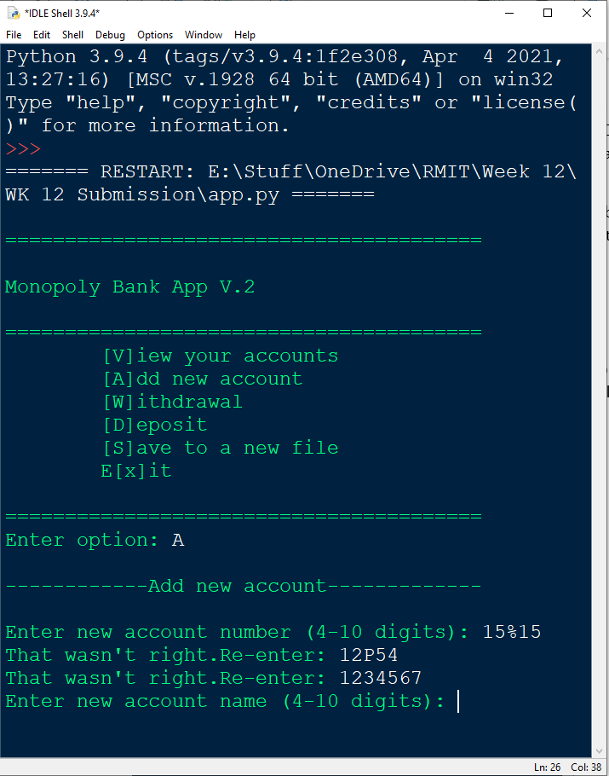
Finally, I have entered my account number 1234567, the program now prompts for an account name.
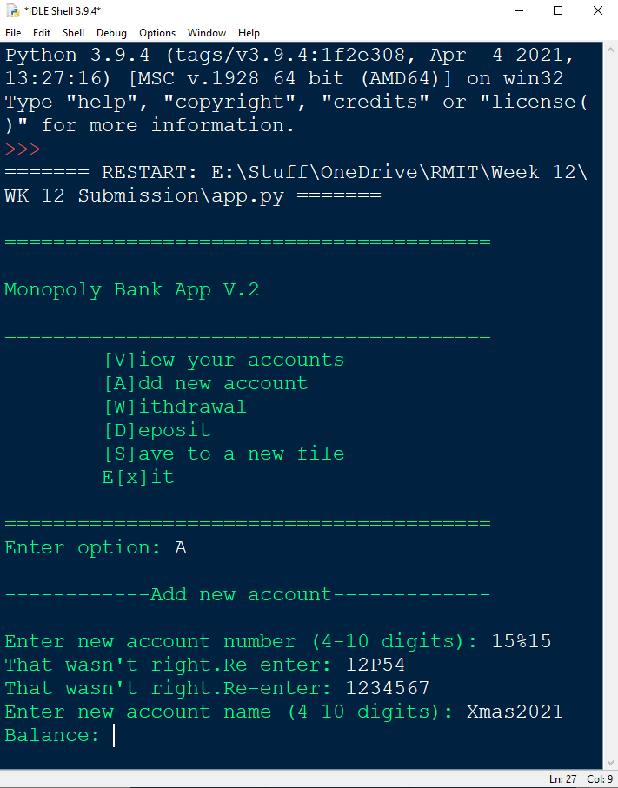
No more than a combination of 10 letters, symbols and numbers are accepted as an account name. No less than 4.
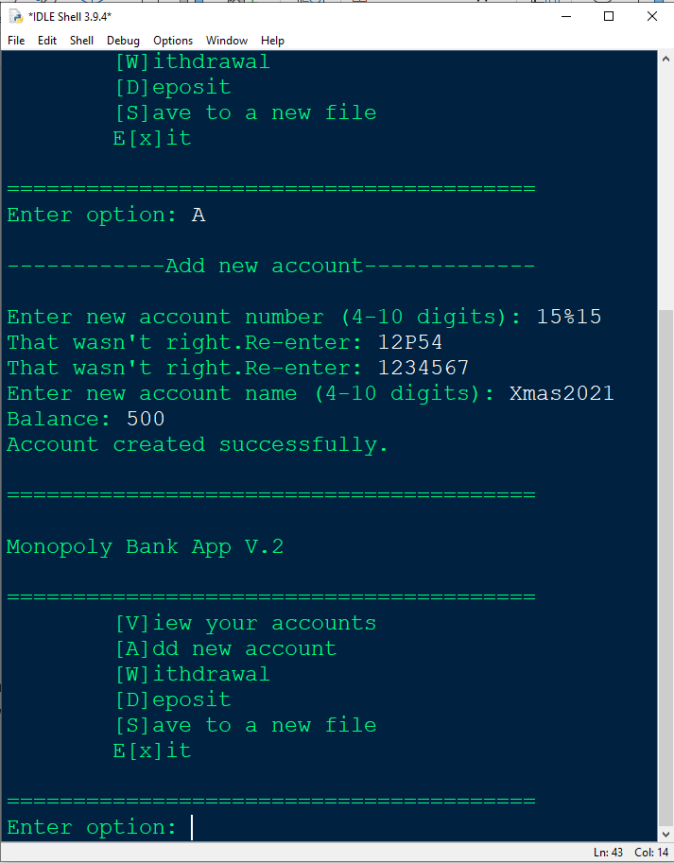
The opening balance above is $500, the program how confirmed creation of account is successful.

If for some reason a typo was entered on the opening balance amount, the program will request a number, or decimal without any symbols or letters as shown in the next example.
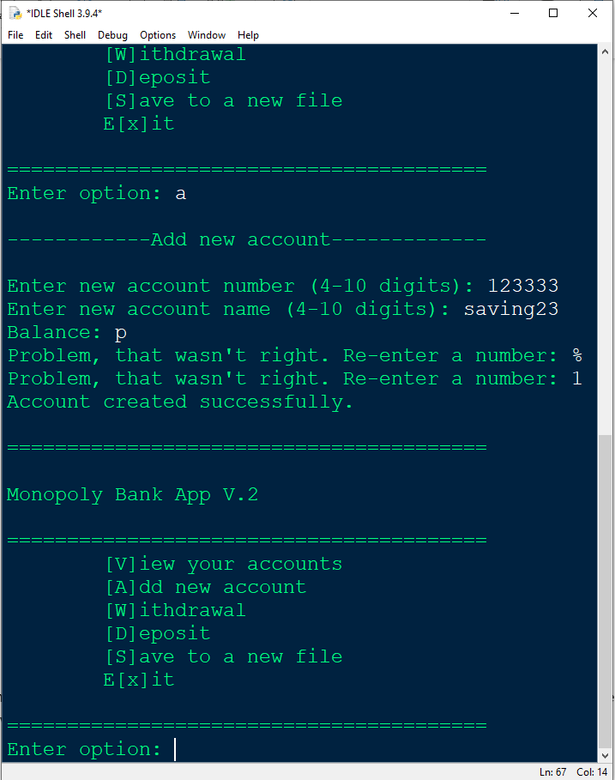

View your accounts

You can view all existing accounts created and/or loaded into the program, by pressing v or V to get the accounts to display on the screen.
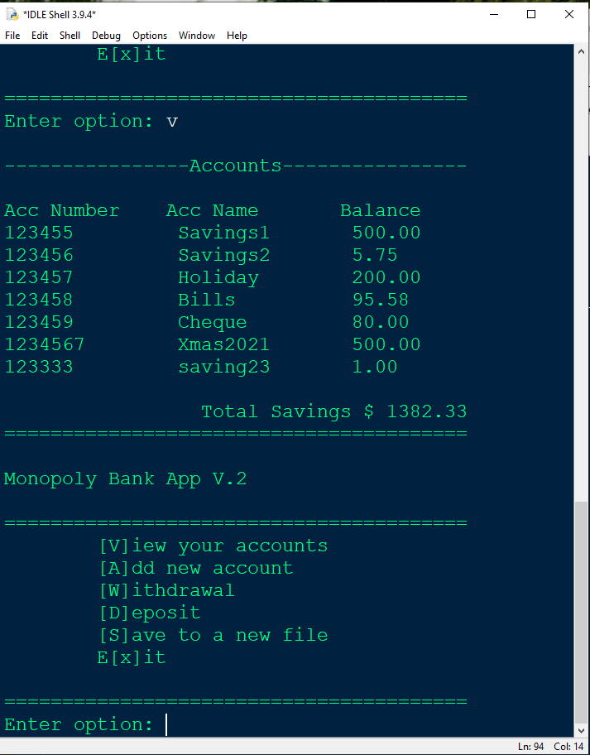
As you can see in the screenshot above, I have 7 accounts listed, where were created and saved to a file.
The main menu will automatically prompt for another menu option.

If the customer chooses view accounts without loading an existing account or creating an account, the program will display as below.
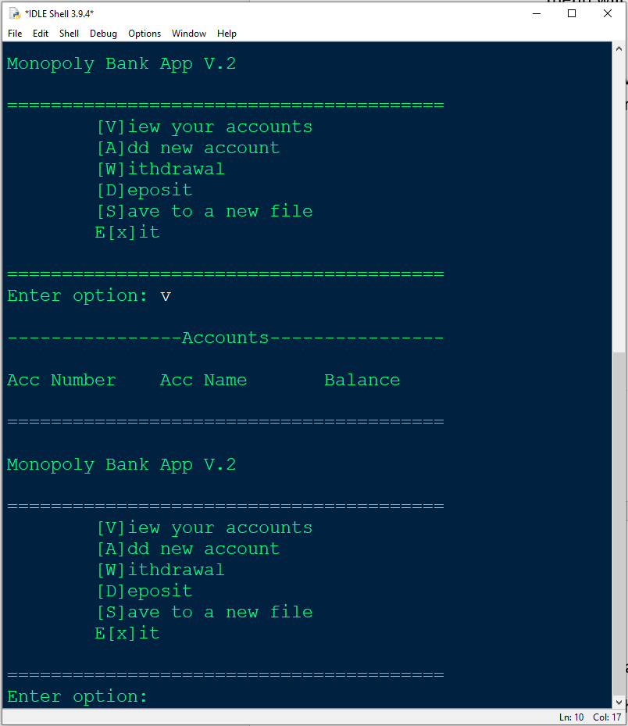

Withdrawals

For withdrawals, enter W or w at the main menu to start the operation.
The program will prompt you to enter the account number that you wish to withdraw money from.
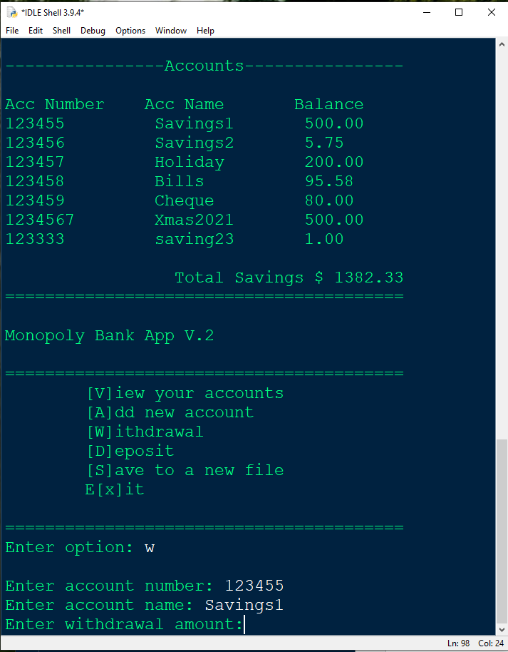
In this example Account 123455 has a balance of $500, if I attempt to withdraw $600 the program will advise the following.
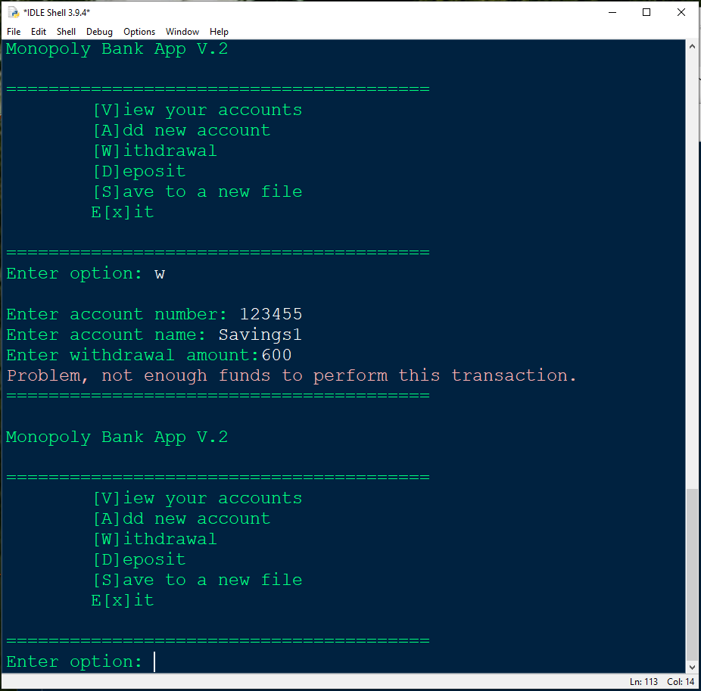
On another attempt to withdraw from the same account, I successfully withdraw $50.
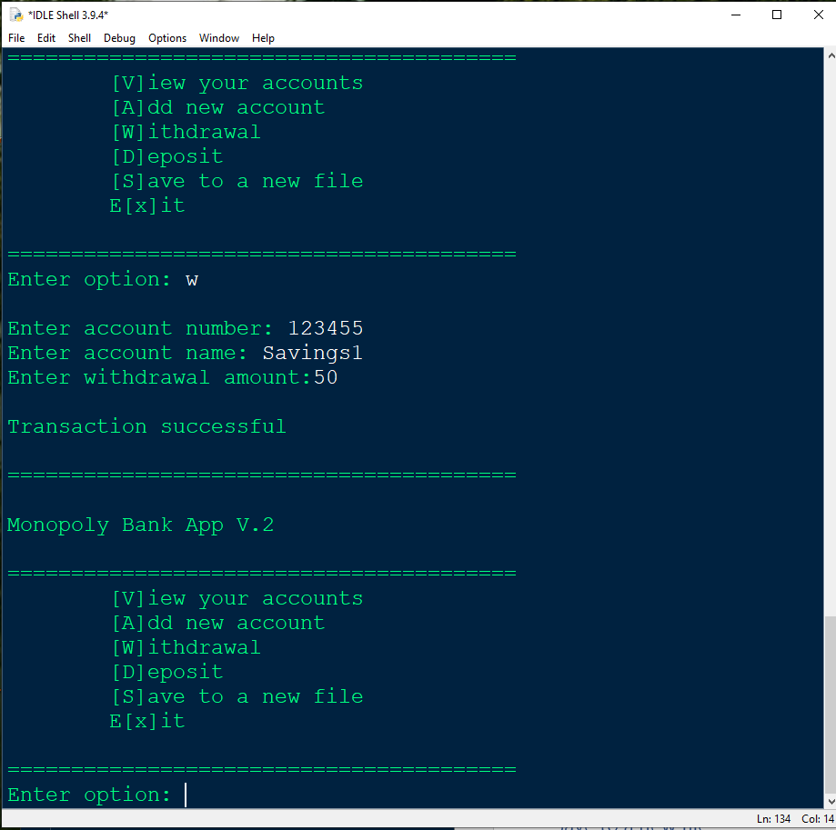

Here is the accounts list to confirm the balance of Savings1 is $450.00
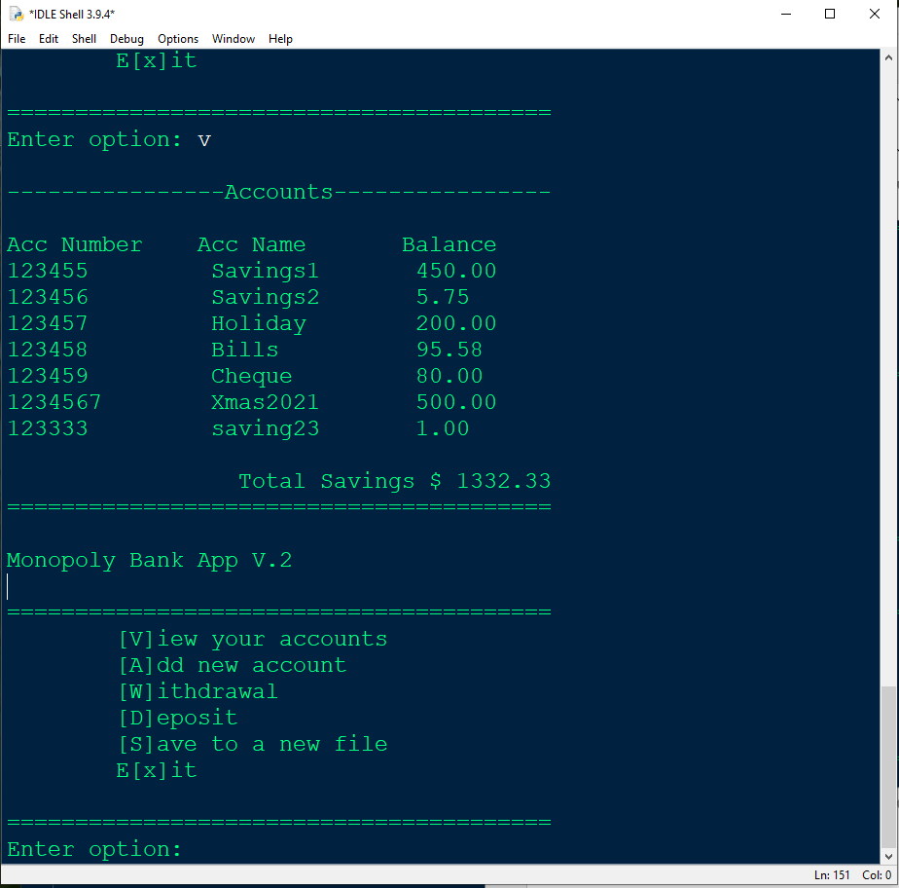

If for some reason you have forgotten the account number or you do not have enough money in the account to make that withdrawal, the program will advise the customer of an error as shown below.
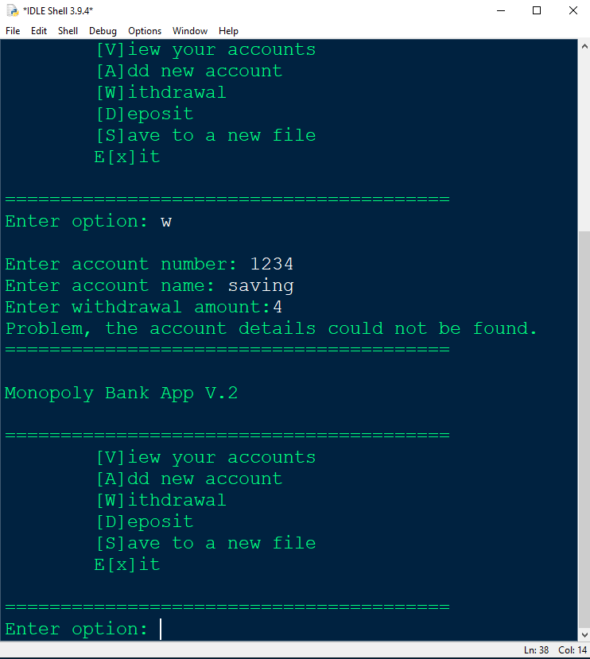

Deposit

To deposit money into an account, enter d or D at the main menu.
The program will ask you for the account number and deposit amount.
In this example I will deposit $50 back into Account number 123455. As you can see in this screen the current balance on Account number 123455 is $450.00
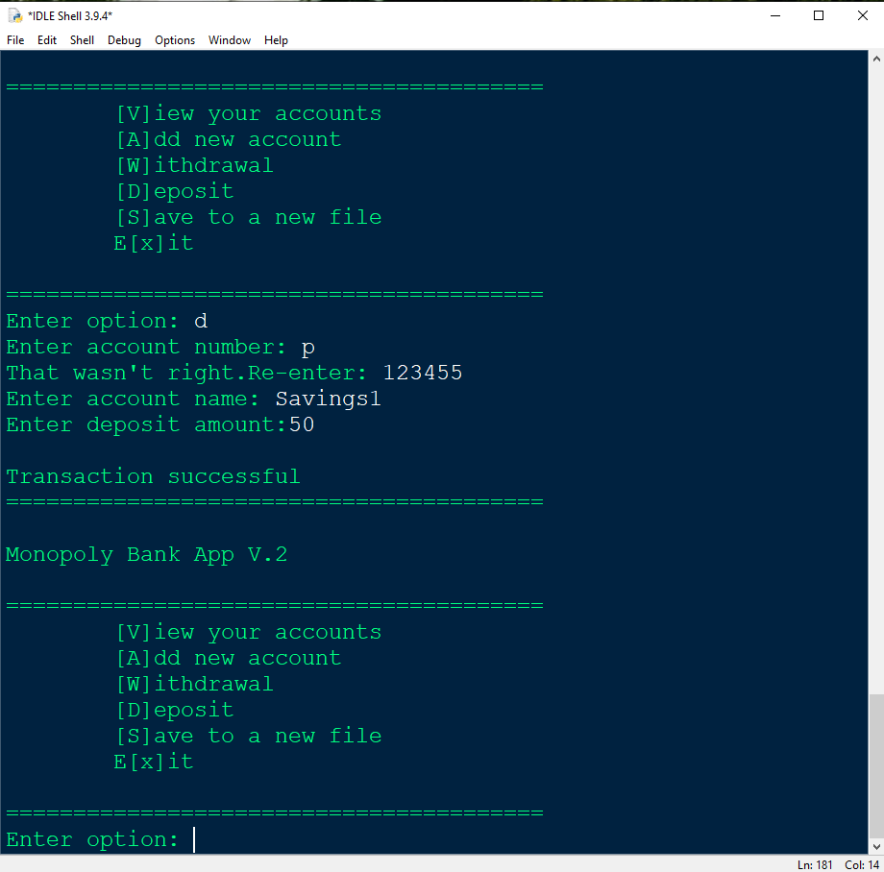
An error was entered and the program has prompted to re-enter the account number.

As you can see the balance is updated to $500 below.
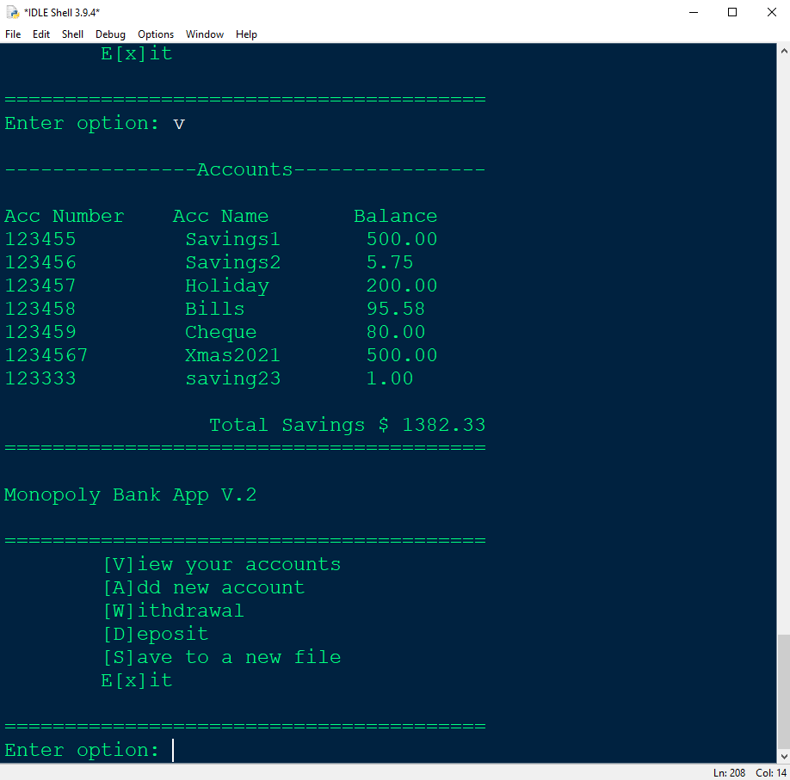

Errors when typing the account number, will prompt the customer to re-enter the account number. If the number entered does not match an existing account, the program will confirm the account details could not be found.
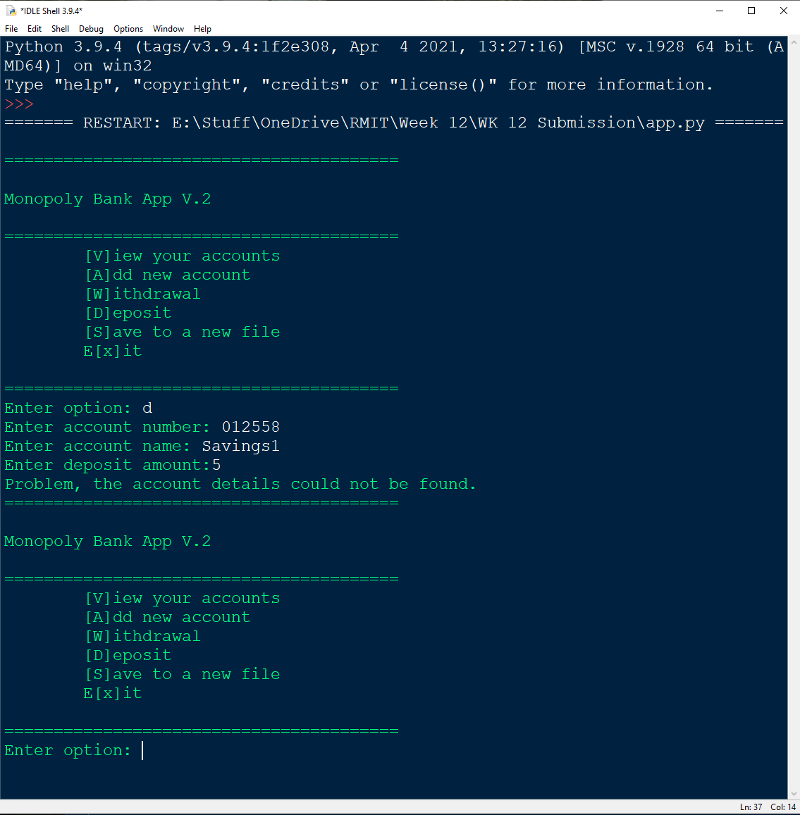

Save to a new file

Although the program will automatically load and save accounts from a specific file, you may want to export this information to a new file. Press S at the main menu and the program will prompt to enter a new file name and it will save a new file to your computer.
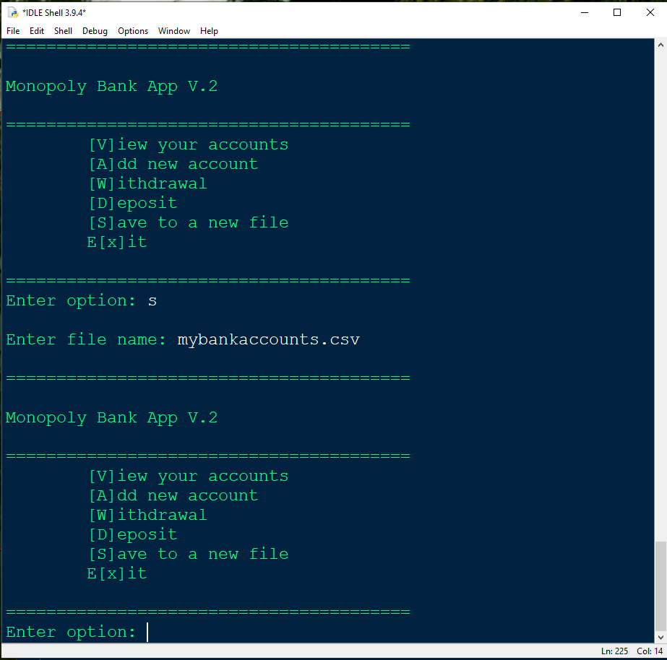

If there was an issue with file, such as there may be a technical issue preventing the program to save. A message will appear to confirm this.
